**SUPERSTORE DATA**

The PowerBI tool is a data analytic tool used for visualization and display of analyzed data

In this analysis, it was used to visualize and display the dataset of a Superstore and the relationship with sales, profit, order and other variables

**Data Source**

The data was sent to the PSP Analytics whatsapp group by our facilitator Joseph Elijah

**Data Processing**

The columns of Sales, Profit, and Discount Columns were formatted to display as currency values under the column tools

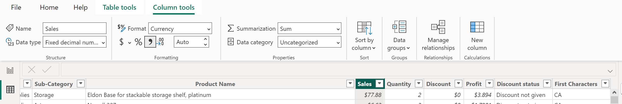

**EXPLORATORY DATA ANALYSIS**

The Sales, Profit and Discount values were first summed up using the ‘measure’ function to achieve the total values in the year

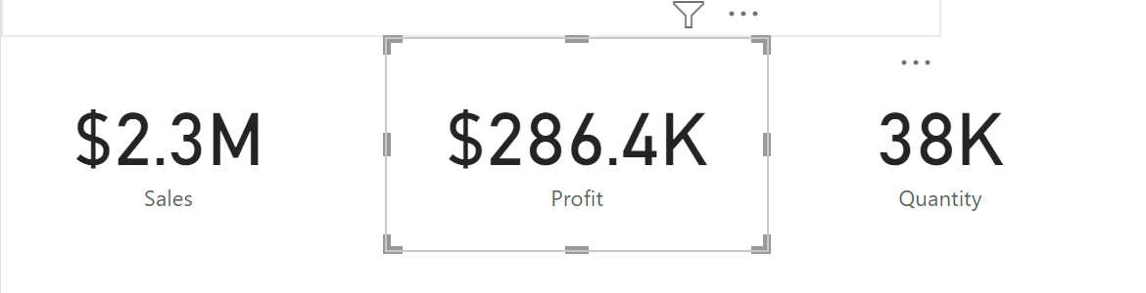

From the image above, the total number of sales in the year was $2.3M, total profit was $286.4K, and the total quantity of goods sold in that year was 38K

**Sales by Region**

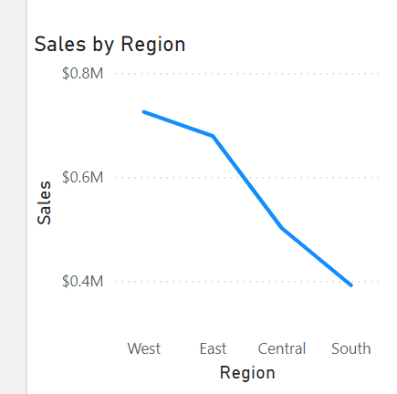

The Region with the highest sales in the year is the West and the region with the lowest sales in the year is South

**Profit by Category**

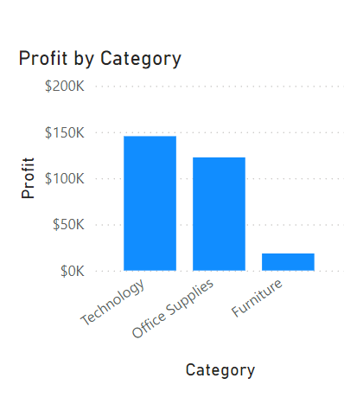

The category of goods with the highest profit margin is Technology while that with the lowest is Furniture

**Profit by Segment**

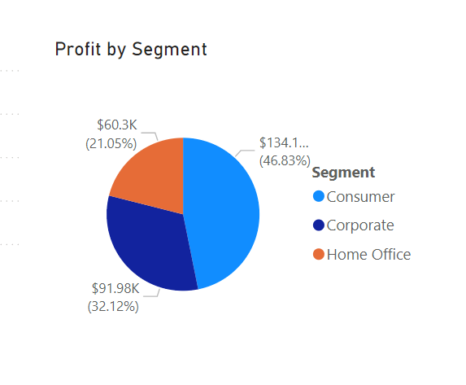

The segment with the highest profit is Consumer and the Home office produced the lowest profit

**Profit by Year**

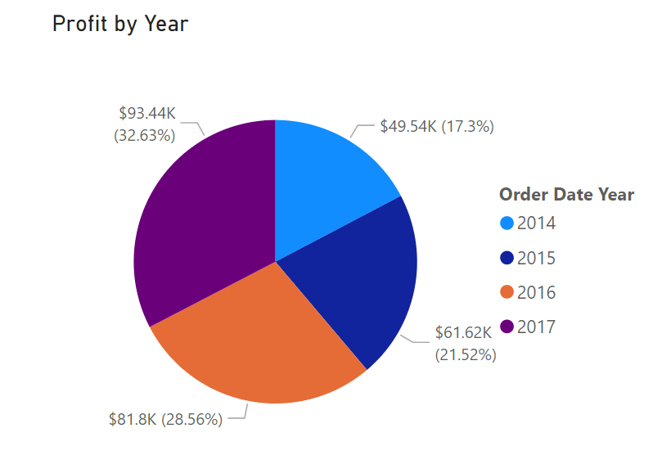

The year 2017 had the highest profit margin of about 32.63% while the lowest was 2014 with a profit margin of about 17.3%

**Quantity by Ship Mode**

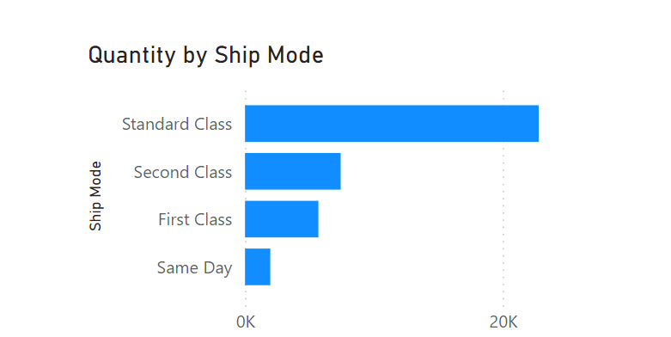

The Standard class ship mode is observed to be used to deliver the more quantity of goods while fewer quantity of goods were delivered Same day.

**RECOMMENDATIONS**

From the data presented, the sales margin in the south which shows to be lower proves that there should be attention directed to the south to increase the awareness of the products and hence, the sales.

**CONCLUSION**

The analysis from the Superstore dataset using the Power BI visualization tool shows the profit margins from various segments, region and the year. We were also able to analyze the regions with the largest and lowest sales and the mode of delivery that delivered the highest quantity.